Skills checks cover pre-requisite material needed for the third unit of the course, applications of derivatives. Answer the following questions neatly and completely. Calculators are not allowed.

- Given , factor out and write your final answer using only positive exponents.

- Given , factor out and write your final answer using only positive exponents.

- Given, factor out and write your final answer using only positive exponents.

- Solve the inequality . Give your answer in interval notation.
We know that when
We know that is undefined when
Therefore, we put these values on a number line (representing the x-axis) and we check to see the behavior of the expression on the intervals on either side (and in between) these values.
If then
If then
If then
Since we are interested in when the expression is greater than (or equal to) zero we have the solution set:
- Solve the inequality . Give your answer in interval notation.

We know that when
We know that is never undefined.
Therefore, we put these values on a number line (representing the x-axis) and we check to see the behavior of the expression on the intervals on either side (and in between) these values.
If then
If then
If then

Since we are interested in when the expression is greater than zero we have the solution set:

- Solve the inequality . Give your answer in interval notation.

We know that when
We know that is never undefined.
Therefore, we put these values on a number line (representing the x-axis) and we check to see the behavior of the expression on the intervals on either side (and in between) these values.
If then
If then

Since we are interested in when the expression is less than (or equal to) zero we have the solution set:

- Solve the equation:

- Solve the equation:

- Solve the equation: .

- Solve the equation for .

We start by isolating. We see that

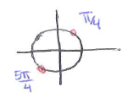 | are both possible solutions.  Any angle coterminal with these angles are also solutions.  Therefore our solutions are: where k is an integer.  Since the locations of these solutions are separated by a distance of we can combine these equations into a single equation.  where k is an integer.

- Solve the equation for .
We would like to start by first isolating the . We see that .

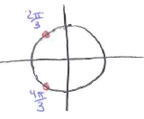 | are both possible solutions.  Any angle coterminal with these angles are also solutions.  Therefore our solutions are: where k is an integer.

- Solve the equation for .

We would like to start by first isolating the . We see that .

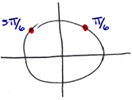 | are both possible solutions.  Any angle coterminal with these angles are also solutions.  Therefore our solutions are: where k is an integer.
- Find the volume of a cylinder with height of 5cm and a diameter of 2cm.

The volume of a cylinder is given by .
Therefore,

- Find the radius of a circle that has an area of .

The area of a circle is given by .
Therefore,

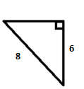
- Determine the length of the remaining side of the triangle at the right.

The Pythagorean Theorem states that in a right triangle, where c represents the hypotenuse of the triangle.

Therefore,

